Ex No: 13
Threat Intelligence for SOC
Aim:
To understand and apply threat intelligence in a Security Operations Center (SOC) for identifying, analyzing, and mitigating cyber threats.
Procedure:
- Open a web browser and go to TryHackMe, then log in with your account.
- Search for the room “Threat Intelligence for SOC” and open it.
- Read the introduction to understand the basics of threat intelligence and its role in a SOC.
- Start the room by clicking “Start” or launch the machine if required.
- Go through each task and study the given concepts such as types of threat intelligence, Indicators of Compromise (IoCs), and threat actors.
- Perform the practical activities provided, like analyzing IPs, domains, or hashes using available tools.
- Answer all the questions in each task based on your analysis and verify the answers.
- Take notes of important points and capture screenshots if needed for record submission.
- Complete all tasks until the room shows 100% completion.
- Log out from TryHackMe after finishing the experiment.

Task 1: Introduction
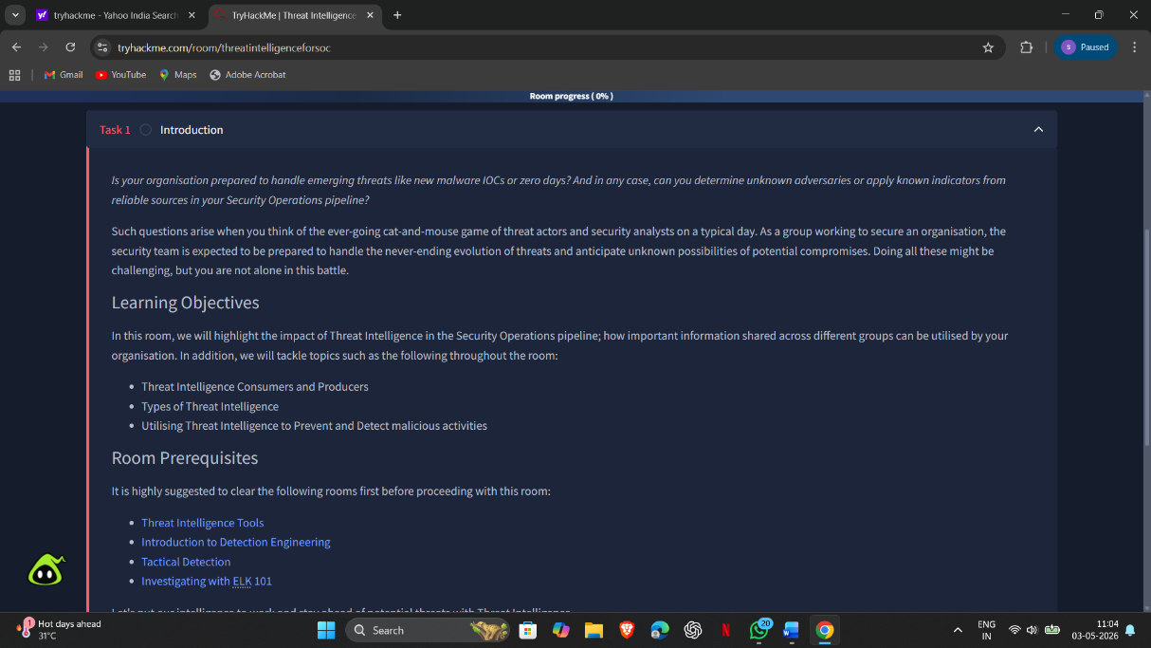

Task 2: Threat Intelligence Feeds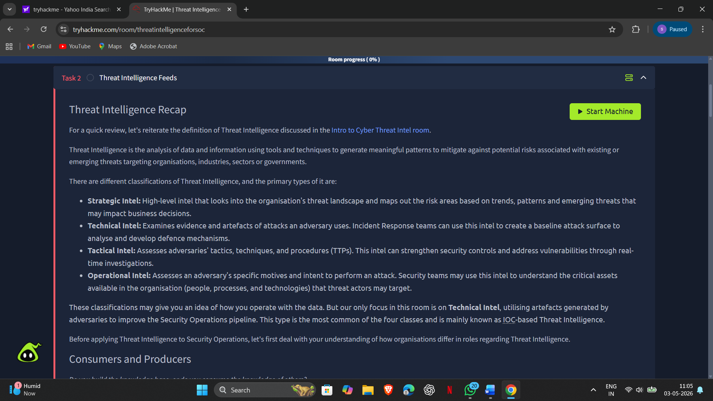
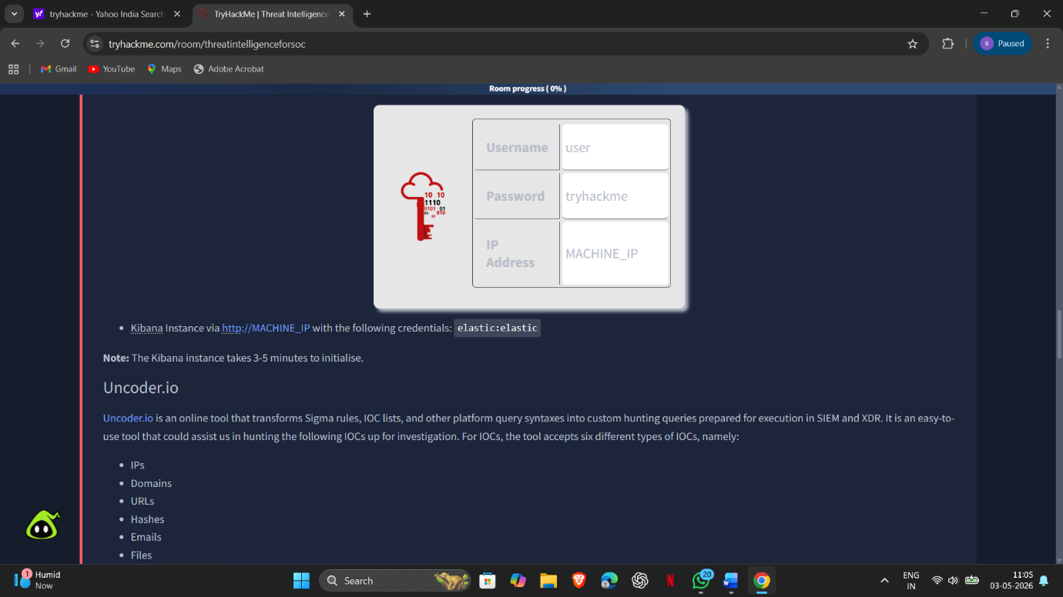
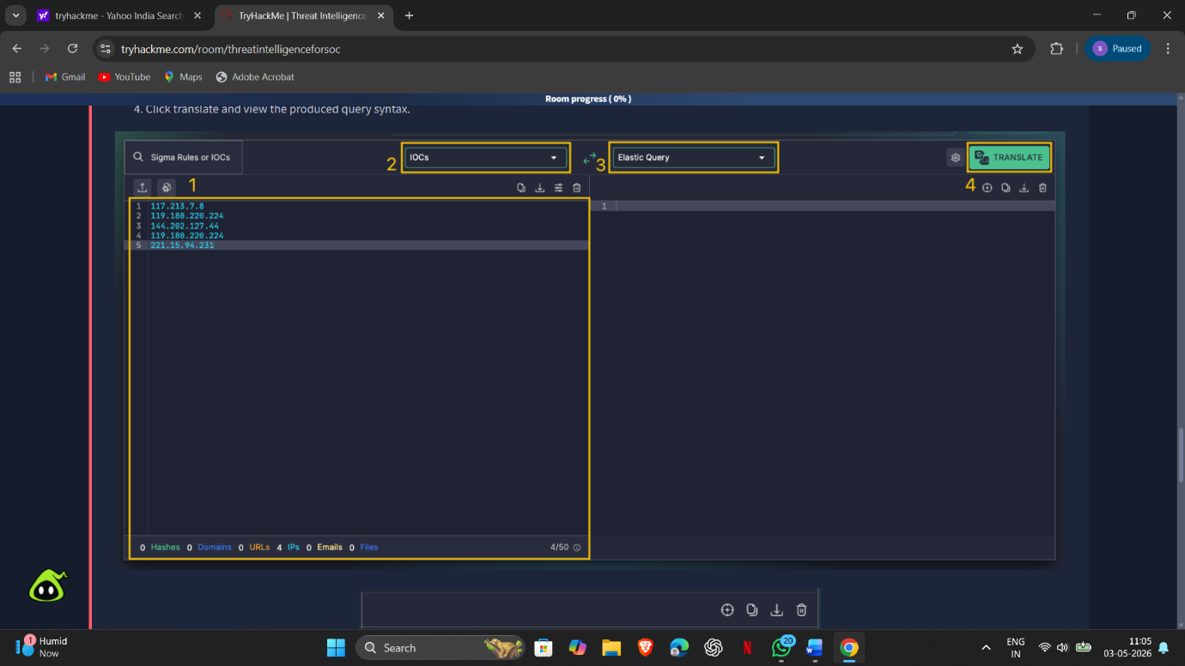

Task 3: Intelligence-Driven Prevention
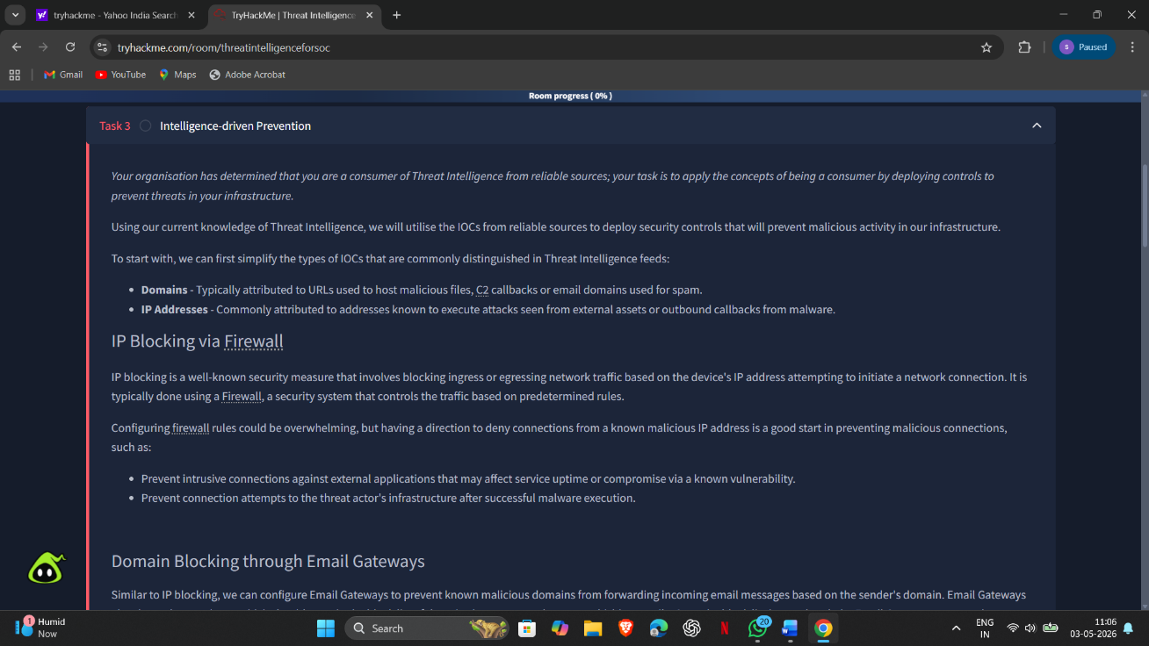
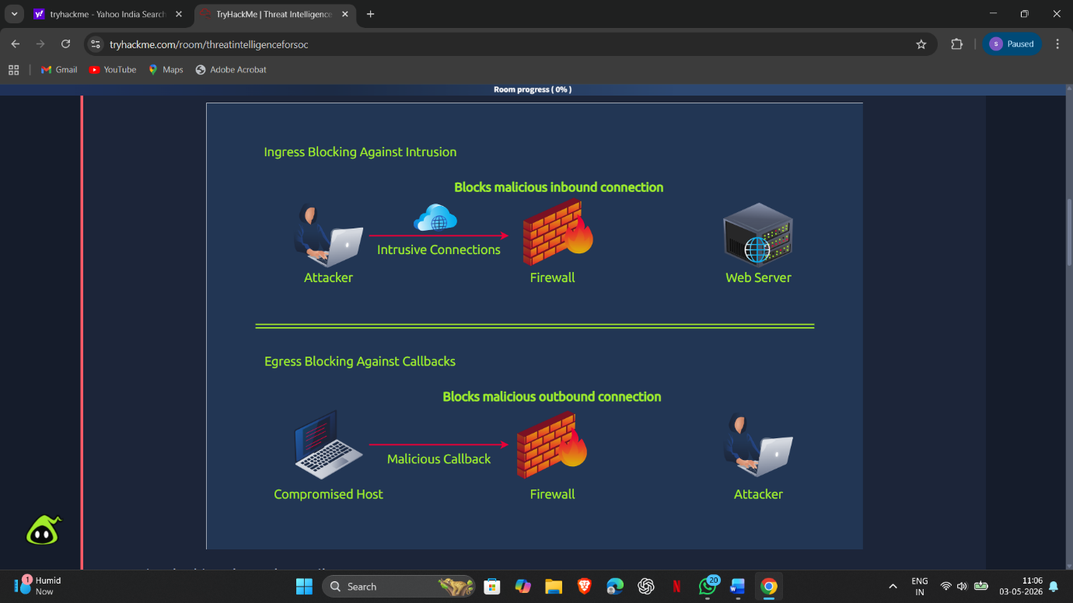
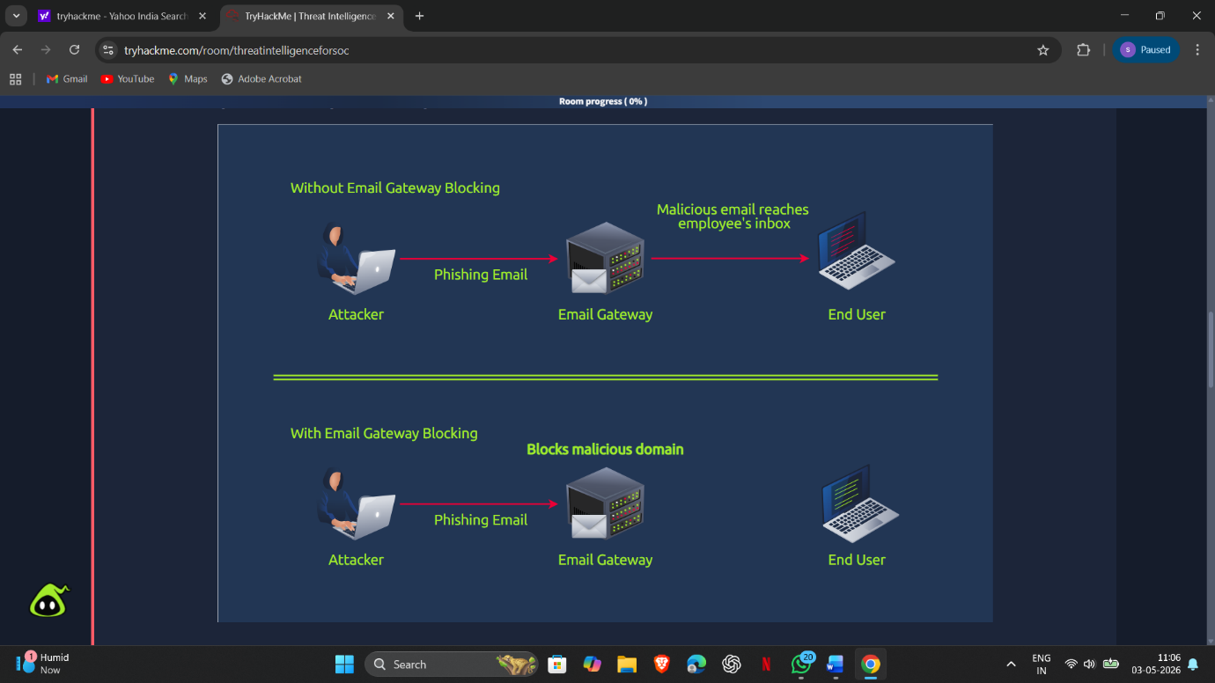

Task 4: Intelligence-driven Detection
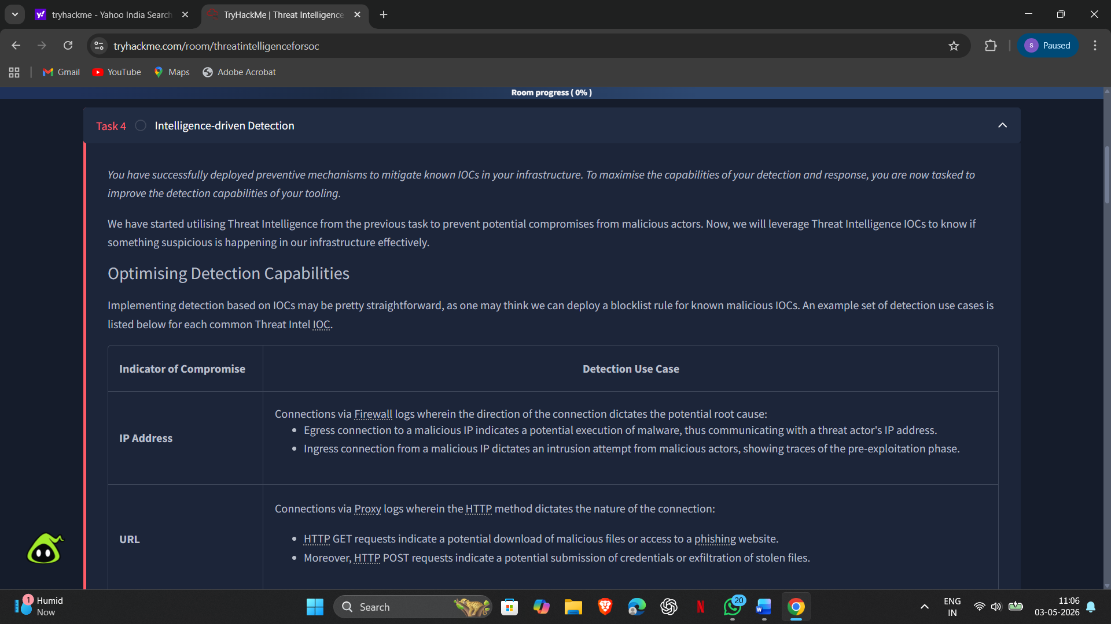

Result:
Successfully understood and applied threat intelligence concepts in a SOC environment. Identified and analyzed Indicators of Compromise (IoCs), studied threat actors and attack patterns, and utilized threat intelligence techniques to improve detection and response to cyber threats.

